Student document Verification Technical Document (SDVTD)

**1.Login Page**

Students must have to first click on the link 'Apply here for Educational Details verification For Company/Agency’.

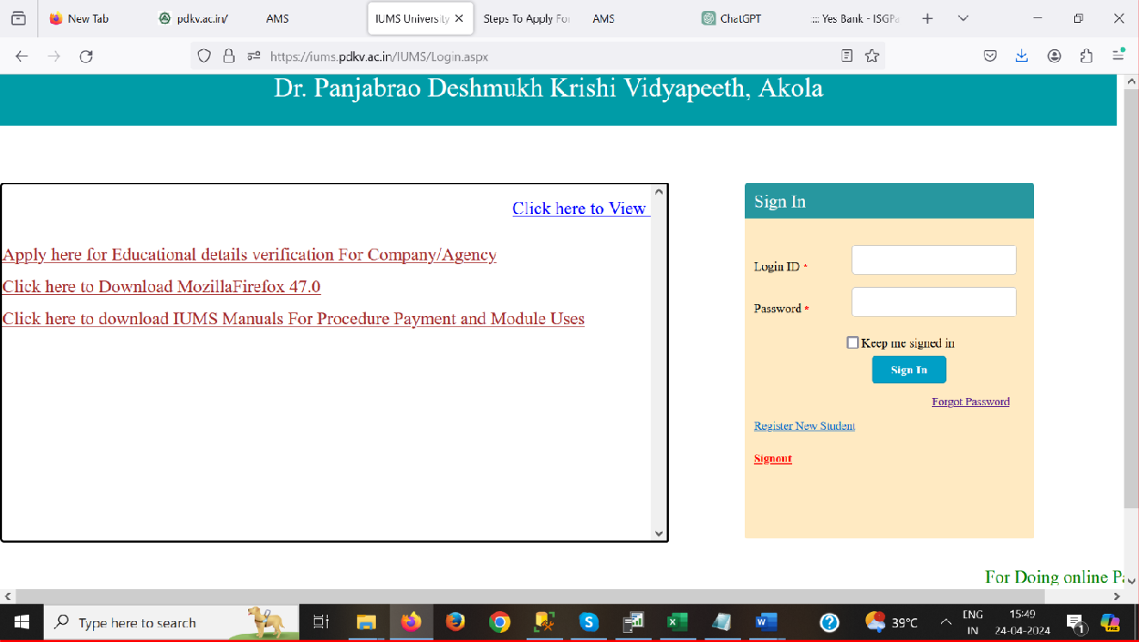

**2.Student Document Verification**

After clicking on the link, this page will be displayed. This is the main page of the Student Document Verification Module.

Note:- For the UU series and later enrollment number series, use the '/' format (e.g., UU/123); otherwise, use the '-' format (e.g., MM-123).

**2.1 Add Details Of Company**

In this page, students have to fill out their Details and company profile details , and then click on the 'Save' button. After clicking on the 'Save' button there details will be saved in database

**2.2 Upload Documents**

After saving data successfully, the student has to upload the required documents. First, click on the checkbox, then browse for the photo, and enter the purpose of verification. Finally, click on the upload button. Documents should be in JPG, PNG, or JPEG format and less than 200KB.Each document have 500rs fees. A screenshot of a computer

**2.2.1 View File**

After successfully uploading the document, the student will view the file by clicking on "view file."

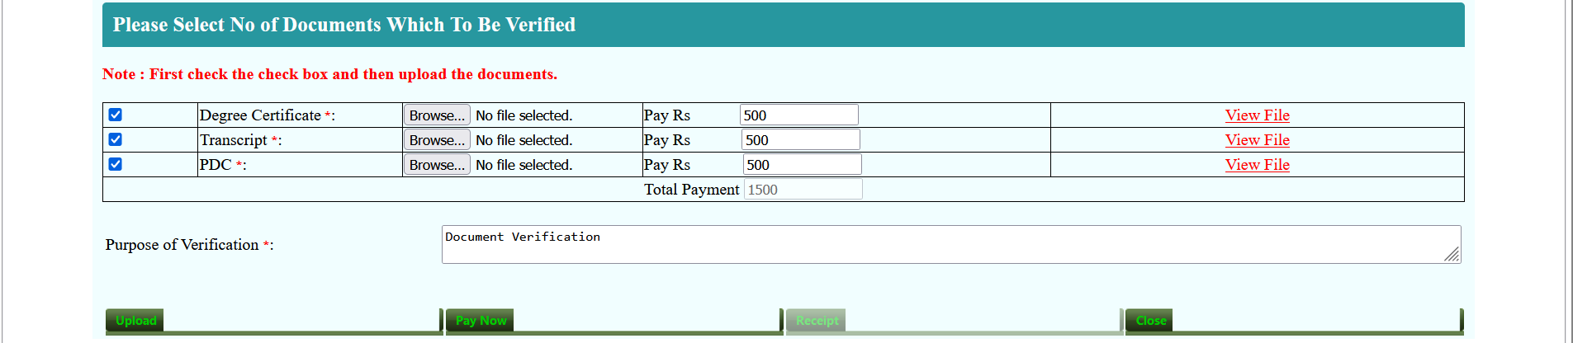

**2.3 Payment**

After uploading all required documents, the "Pay Now" button will become enabled. Students have to click on the "Pay Now" button to initiate the total payment.

When the "Pay Now" button is clicked, then page will be redirect to the payment page.

A window will be displayed, which will have credit card, debit card, net banking, and UPI payment options. Students have to select one option for payment.

**2.3.1 Credit Card**

If the student selects the Credit Card option, the following window will be displayed for payment. Students have to fill Card number and Card holder name

**2.3.2 Debit card**

If the student selects the Debit Card option, the following window will be displayed for payment. Students have to fill Card number and Card holder name.

**2.3.3 UPI**

In the UPI method, there are two options for payment:

1. UPI ID
2. QR code

For (1) UPI ID: Students have to select the UPI ID option to make payment using their UPI ID. They have to enter their UPI ID and make payment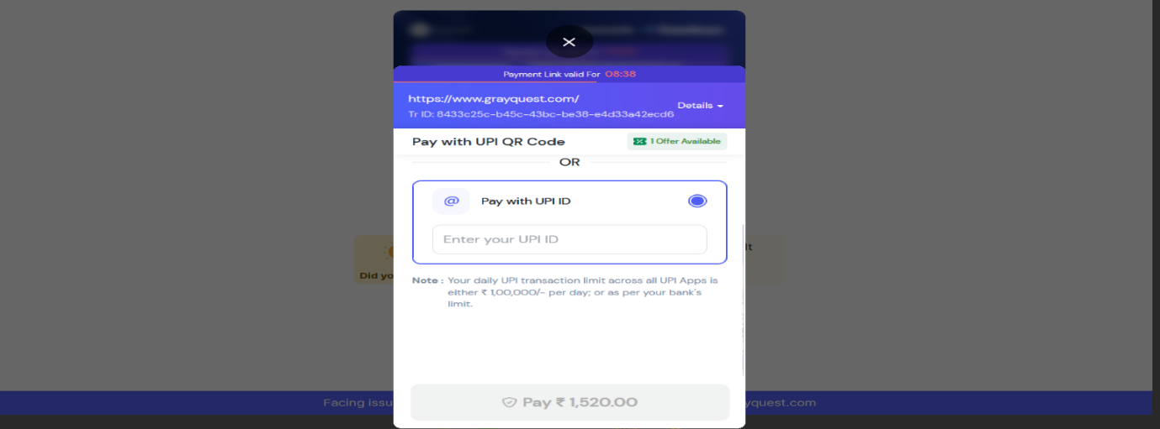

For (2) QR Code: Students have to select the QR Code option to make payment. They have to scan their QR code and make the payment

**2.3.4 Net Banking**

Students have to select the Net banking option to make payment. They have to search for their bank and make the payment.

**2.4 Receipt**

After completing the payment process, the student will be redirected to the main page, where they will need to click on the 'Receipt' button to generate the receipt.

After clicking on the "Receipt" button, the receipt will be generated.

**2.5 View Previous Receipt**

"View Previous Receipt" allows you to access and review the details of your past transactions, whether it's for verifying payments or simply keeping records. This feature offers convenience and transparency, empowering you to dive into your transaction history effortlessly. Students have to enter their enrolment number, transaction ID, degree, and document type, and then click on the search button.

